**Unit-4**

1. What is a logical address?

The address generated by CPU is called logical address.

1. What is a physical address?

The address used to load data into memory is called physical address.

1. Name the methods of memory allocation in OS.

1.Contigous

2. Non Contigous

1. Name the solution to the problem of external fragmentation.

Compaction i.e.,all holes in memory are moved to end so that a new process can be stored in that space.

1. What is the problem with best-fit memory allocation?

Consumes a lot of processor time for searching the block which is close to required size

1. What is frame?

The memory divided into fixed size partitions called frame.

1. What do you mean by page table?

Page table has page table entries where each page table entry stores a frame number

1. Every address generated by the CPU is divided into two parts namely page number and offset value.
2. What is the size of a page typically?

Power of 2.

1. TLB stands for Translation Lookaside Buffer.
2. Define hit ratio.

If the page requested is found in the asoociated memory,it is called a hit.The hit ratio is 80%,if 80% of the pages requested are in associated memory i.e need not be loaded from the secondary memory.

1. A common approach for handling address spaces larger than 32 bits is to use a hashed page table.
2. What does an inverted page table contains?

It contains the address space information of all processes in execution.

1. Name any two page replacement algorithms.

1.FIFO (First In First Out)

2.LRU (Least Recently Used).

1. Name the page replacement algorithm that does not suffer from Belady’s anomaly.

LRU

1. Which disk scheduling algorithm is optimum among the following disk scheduling algorithms in most of the cases?

a) FCFS b) SSTF c) SCAN d) LOOK

1. What would be the number of bits required to represent each page in a page table for 32-bitlogical address space with page size of 4Kbytes? [Assume that 1 word = 1 byte] _______.
2. The time taken to move the disk arm to the desired cylinder is called the
   1. Positioning time

b) random access time

c) seek time

d) rotational latency

1. Memory management technique in which system stores and retrieves data from secondary storage for use in main memory is called

a) Fragmentation

b) paging

c) mapping

d) none of the mentioned

1. Mapping of file is managed by
2. file metadata

b) page table

c) virtual memory

d) file system

1. What does Belady’s anomaly related to________
2. Disk Scheduling b) CPU Scheduling
3. Deadlocks d) Page replacement algorithm
4. The segmented memory is provided mainly ___________.

a) for higher speeds b) to maintain compatibility with old processors

c) for ease of application programming d) simple hardware

1. When a computer is "swapping", it is___________.
   1. moving data from the hard drive to the floppy drive
   2. moving data from memory to the swap file on the hard drive
   3. moving data between registers in memory
   4. none of the above
2. Logical memory is broken into blocks of the same size called _________

a) Frames b) Pages c) Bcking store d) None of these

1. If there are 32 segments, each of size 1Kb, then the logical address should have :

a) 13 bits b) 14 bits c) 15 bits d) 16 bits

1. Consider a machine with 64 MB physical memory and a 32-bit virtual address space. If the page size is 4KB, what is the approximate size of the page table?

2MB

1. File system fragmentation occurs when.

a) unused space or single file are not contiguous b) used space is not contiguous

c) unused space is non-contiguous d) multiple files are non-contiguous

1. The time taken for the desired sector to rotate to the disk head is called rotational latency.

**10 Marks**

1. On a disk with 1000 cylinders, numbers 0 to 999, compute the number of tracks the disk arm must move to satisfy all the requests in the disk queue. Assume the last request serviced was at track 345 and head is moving to track 0. The queue in FIFO order contains requests for the following tracks: 123, 874,692, 475, 105, 376. Perform the computation for the following disk scheduling algorithms.

A) FCFS B) SSTF C) SCAN D)LOOK E)C-SCAN F)C-LOOK

1. Consider the following page reference string1,2,3,4,5,2,4,1,6,7,8,7,8,6,7,8,9,5,4,4,5,3. How many page faults would occur for the FIFO and LRU replacement algorithms? Assume four frames and all frames are initially empty.
2. Explain the following concepts in detail.
   1. Demand Paging 6M
   2. Logical Versus Physical Address Space 4M
3. Explain Structure of the Page Tables in detail
4. Explain the following concepts in detail.
   1. Paging 6M
   2. Segmentation 4M

Unit-5:

1. Name some common file types.

Text file

Object file

Executable files

Audio files

1. What are the file access methods?

1.Sequential access

2.Direct access

3.Indexed sequential access

1. Give a diagrammatic example of index and relative files.

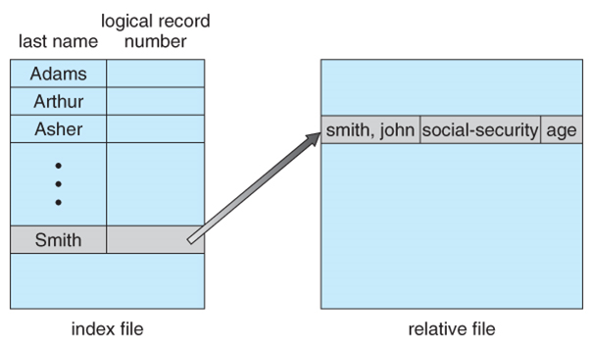

1. Show the typical file-system organization.

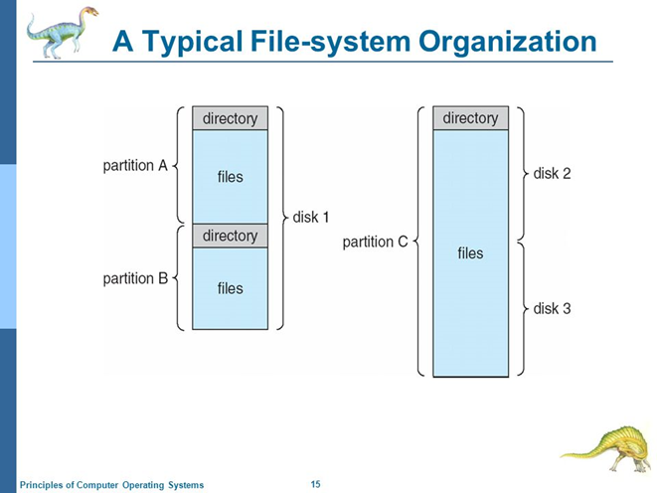

1. Name any three schemes for defining the logical structure of a directory.

1. single level directory

2. Two Level Directory

3. Tree structured directory

4. Acyclic graph directory

1. What are the types of path names?

1.Absolute

2.Relative

1. Give an example of acyclic-graph directory structure.

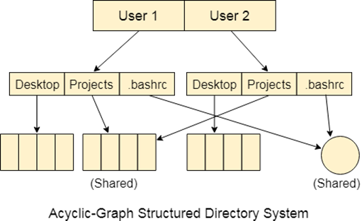

1. Define a mount point in file structure.

It is directory in currently accessible filesystem on which an additional filesystem is mounted.

1. State the classifications of users in connection with each file.

1.Owner

2.Group

3.All users

1. Give the organization of a typical file-control block.

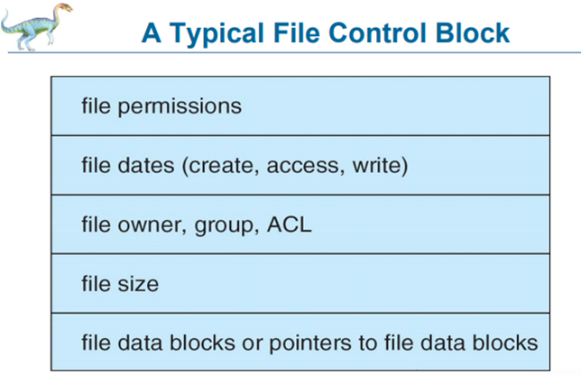

1. What does the root partition contains.

It contains enough software & data to boot a system.

1. What are the major methods of allocating disk space?

1.contiguous allocation

2.Linked allocation

3.Indexed allocation

1. Name any two disk scheduling algorithm.

1.FCFS

2.LOOK

1. Define a file in operating system.

It is named collection of related information that is recorded on secondary storage.

1. Name some of the attributes of a file.

1.Name

2.Identifier

3.protection

4.size

5.Location

1. What is the extension name executable file in windows operating system?

a) .exe b) .avi c) .wav d) .java

1. If file size is large and if it is to be accessed randomly then which of the following allocation strategy should be best to use in a system?

a) Contiguous allocation c) Linked allocation

b) Indexed allocation d) None of these

1. A file system uses the contiguous space allocation mechanism for disk space allocation. For better utilization of disk space, this file system must use.
   1. A garbage collection mechanism b) A disk compaction mechanism

c)A linkedblock allocation mechanism d)An indexed-block allocation mechanism

1. When two users keep a subdirectory in their own directories, the structure being referred to is

a) tree structure b) cyclic graph directory structure

c) two level directory structure d) acyclic graph directory

1. Which table contains the information about each mounted volume?

a) mount table b) system-wide open-file table

c)  per-process open-file table d) all of the mentioned

1. What are the typical operations on file?

1.create

2.write

3.Read

4.Truncate

5.Delete

6.Reposition

1. Define Relative Address

An address specified by indicating its distance from another address.

1. Define Absolute Address

An explicit identification of hardware such as memory location or location within a device.

1. volume control block consists non-relocatable block.
2. I/O control consists registers for communication.
3. Define master file directory

It is a database in which information about every file & directory on NT filesystem volume is stored.

10 marks:

Unit-5

1. Explain all the file allocation methods in detail. 10M
2. Explain about various directory structures 10M
3. Write a short note on
4. Directory implementation 4M
5. Free-space management 6M
6. Write a short note on
7. File system structure 6M
8. File system Mounting 4M
9. Write a short note on
10. File Access Methods 6M
11. Directory Implementation 4M